AI MENTAL HEALTH UK
Task - Baseline stats model
Duration – 3-6 May
Name – Rushay Gopani
Domain - Data Science

DS-2 Report

Exploratory & Hypothesis-Based Mental Health Analysis using APMS 2014

1. Introduction
Mental health disorders are one of the major public health concerns affecting people across different age groups and social backgrounds. Understanding how mental health conditions vary across gender, age, trauma exposure, and regions is important for identifying vulnerable populations and improving mental health support systems.
This analysis was performed using the Adult Psychiatric Morbidity Survey (APMS) 2014 dataset published by NHS Digital and NatCen Social Research. The study focused on exploring patterns in common mental disorders (CMDs), suicidal thoughts, PTSD prevalence, and regional mental health variation across England.

2. Objectives
The main objectives of DS-2 were:
- To analyse CMD prevalence across age and gender groups.
- To compare different mental disorder categories.
- To study suicidal thoughts and self-harm prevalence.
- To analyse PTSD prevalence across demographic groups.
- To identify regional differences in CMD prevalence.

3. Dataset Used
The analysis used real APMS 2014 survey tables:
Table | Purpose
Table 2.1 | CMD prevalence by age and sex
Table 2.3 | Disorder-type prevalence
Table 2.11 | Regional CMD prevalence
Table 12.1 | Suicidal thoughts and self-harm
Table 4.1 | PTSD prevalence
Python libraries such as Pandas, NumPy, and Matplotlib were used for extraction, analysis, and visualisation.

4. CMD Analysis
CMD stands for Common Mental Disorder and includes conditions such as anxiety, depression, panic disorder, OCD, and phobias. CMD prevalence refers to the percentage of people showing clinically significant symptoms.
The analysis showed that women consistently had higher CMD prevalence than men across most age groups. Younger adults, especially women aged 16–24, demonstrated the highest prevalence levels.
The findings suggest that younger populations may experience greater emotional and social stress, while women may face higher psychological burden due to social, emotional, and environmental factors.

5. Disorder-Type Analysis
Different CMD disorder categories were analysed using Table 2.3.
The analysis indicated that anxiety-related disorders and depression contributed significantly to overall mental health burden. CMD-NOS also showed noticeable prevalence, while OCD and panic disorder were comparatively lower.
These findings suggest that anxiety and depressive conditions are among the most common mental health challenges within the surveyed population.

6. Suicidal Thoughts & Self-Harm Analysis
Suicidal thoughts and self-harm prevalence were analysed using Table 12.1.
Women aged 16–24 showed the highest suicidal thoughts prevalence at approximately 34.6%, compared to 19.3% among men of the same age group. Suicidal thoughts generally decreased with increasing age.
The results indicate that younger adults, especially young women, represent a highly vulnerable demographic group. Emotional stress, academic pressure, social isolation, and anxiety-related disorders may contribute to higher suicidality among younger populations.

7. PTSD Analysis
PTSD (Post-Traumatic Stress Disorder) is a trauma-related mental health condition that can occur after exposure to traumatic events such as violence, abuse, accidents, or severe emotional stress.
The analysis showed that PTSD prevalence varied across demographic groups. Younger adults generally exhibited higher PTSD prevalence, while women consistently showed higher PTSD positivity than men in several age groups.
Some male groups aged 35–75 also showed elevated PTSD prevalence. This may reflect cumulative lifetime trauma exposure, occupational hazards, delayed psychological effects of trauma, and lower emotional help-seeking behaviour.
Overall, the findings suggest that trauma-related mental health outcomes are strongly associated with age and gender.

8. Regional CMD Analysis
Regional CMD prevalence was analysed using age-standardised prevalence values from Table 2.11.
The analysis showed noticeable regional differences in mental health prevalence across England. South West and West Midlands demonstrated comparatively higher CMD prevalence, while South East showed lower prevalence.
These regional differences may reflect variation in socioeconomic conditions, healthcare access, employment patterns, and environmental stressors.

9. Overall Findings
The DS-2 analysis revealed several important patterns:
- Women consistently showed higher CMD prevalence than men.
- Younger adults represented the highest-risk demographic group.
- Anxiety and depression contributed significantly to CMD burden.
- Suicidal thoughts were highest among younger women.
- PTSD prevalence varied across demographic groups.
- Regional CMD prevalence differed across England.

10. Conclusion
The exploratory and hypothesis-based analysis successfully identified demographic and regional disparities in mental health outcomes using APMS 2014 data.
The findings highlight the importance of targeted mental health interventions for younger adults, women, and trauma-affected populations. The study also demonstrates how real-world NHS mental health data can be used to identify vulnerable groups and support evidence-based public health planning.
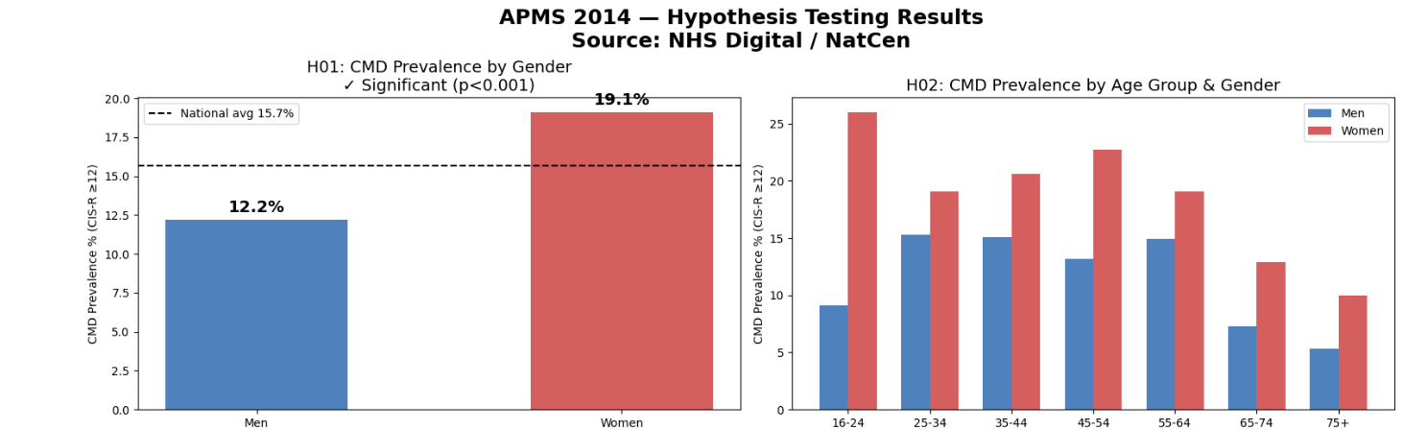
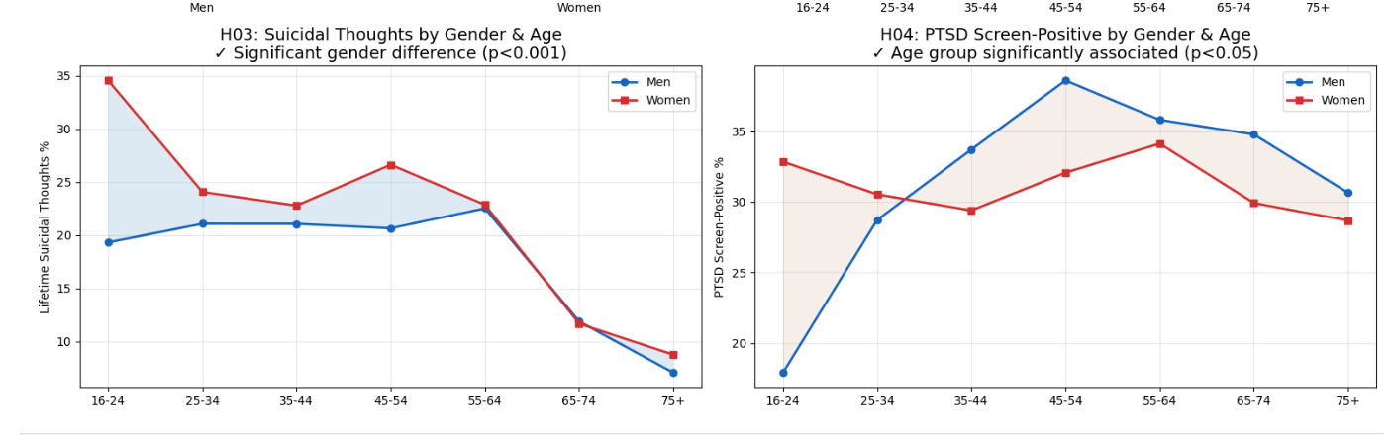

11. References
- NHS Digital — Adult Psychiatric Morbidity Survey (APMS) 2014.
- NatCen Social Research.
- APMS 2014 Chapters 2, 4, 12, and 14 Excel tables.
- Python Documentation.
- Pandas and Matplotlib Libraries.

